**Bài Tập 1: Gradient Descent**

**Bài 1:**

Giải tay trên giấy

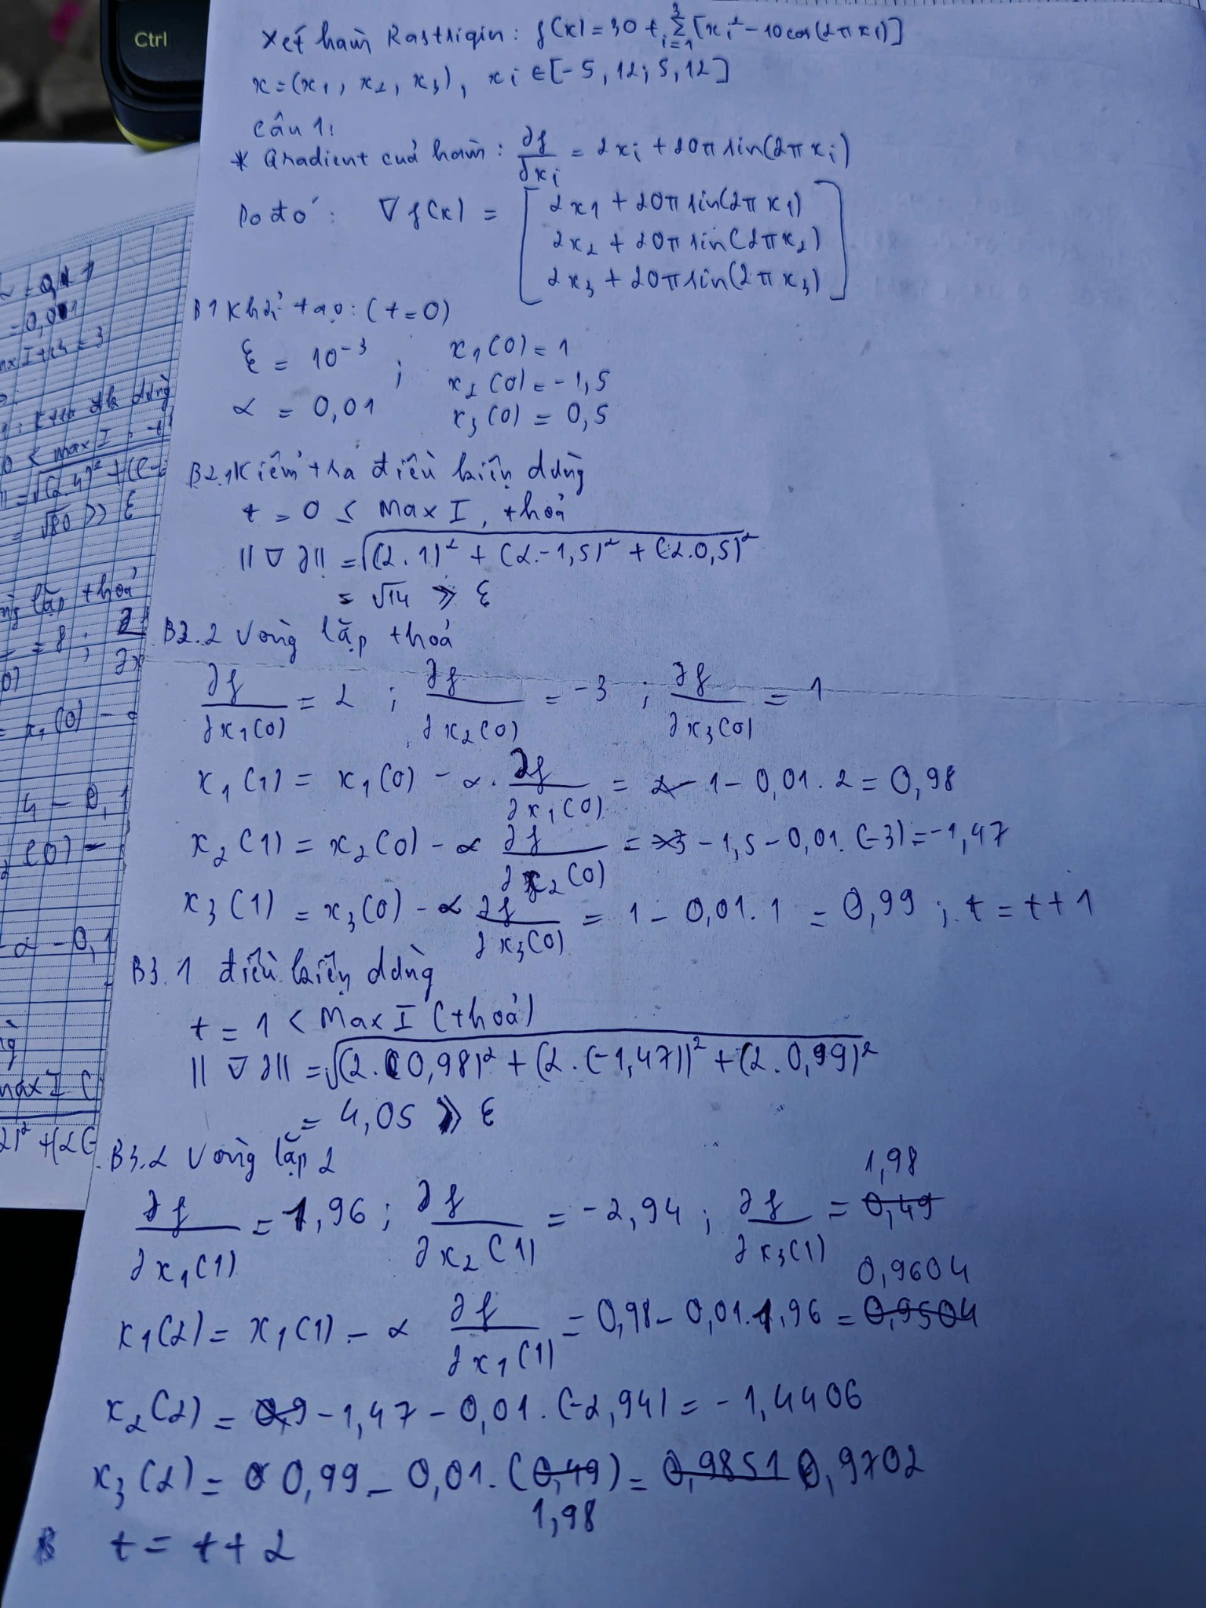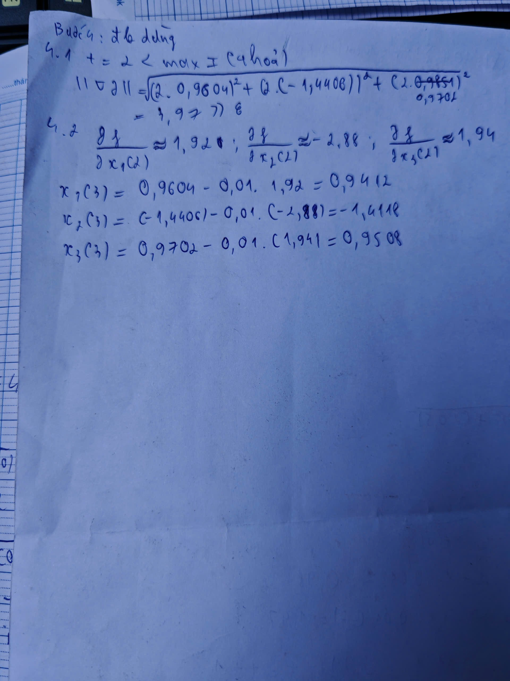

**Bài 2:**

Vẽ lưu đồ của thuật toán Gradient Descent để tối ưu hàm Rastrigin

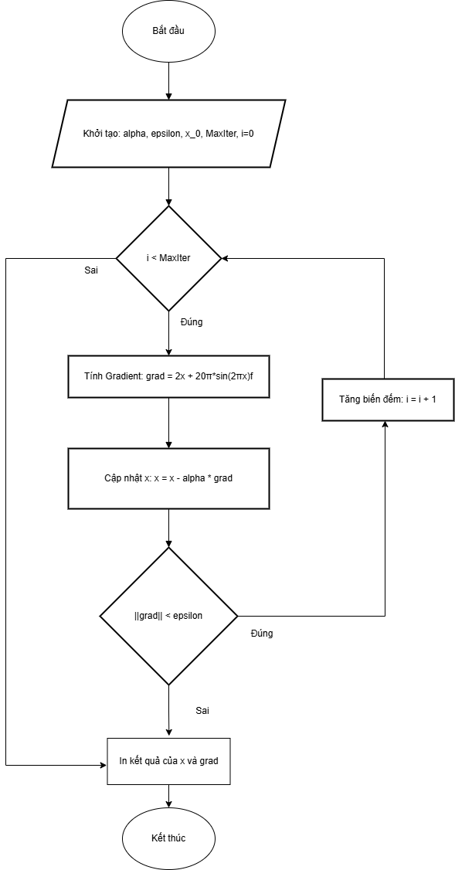

**Bài 3:**

import numpy as np

toc_do_hoc = 0.01

sai_so_cho_phep = 1e-3

chay_toi_da = 1000

so_lan_thu = 20

so_bien = 3

vung_gia_tri = [-5.12, 5.12]

def tinh_ham_so(x):

return 30 + np.sum(x**2 - 10 * np.cos(2 * np.pi * x))

def tinh_dao_ham(x):

return 2 * x + 20 * np.pi * np.sin(2 * np.pi * x)

danh_sach_kq = []

for lan in range(so_lan_thu):

x = np.random.uniform(vung_gia_tri[0], vung_gia_tri[1], so_bien)

for vong in range(chay_toi_da):

grad = tinh_dao_ham(x)

x_moi = x - toc_do_hoc * grad

if np.linalg.norm(grad) < sai_so_cho_phep:

x = x_moi

break

x = x_moi

kq_cuoi = tinh_ham_so(x)

danh_sach_kq.append(kq_cuoi)

print(f"Lan {lan+1}: {kq_cuoi:.4f}")

mang_so = np.array(danh_sach_kq)

print(f"Nho nhat (Min): {np.min(mang_so):.4f}")

print(f"Lon nhat (Max): {np.max(mang_so):.4f}")

print(f"Trung binh (Mean): {np.mean(mang_so):.4f}")

print(f"Do lech (Std): {np.std(mang_so):.4f}")

**Bài 4:**import numpy as np

import matplotlib.pyplot as plt

toc_do_hoc = 0.01

sai_so_cho_phep = 1e-3

chay_toi_da = 1000

so_lan_thu = 20

so_bien = 3

vung_gia_tri = [-5.12, 5.12]

def tinh_ham_so(x):

return 30 + np.sum(x**2 - 10 * np.cos(2 * np.pi * x))

def tinh_dao_ham(x):

return 2 * x + 20 * np.pi * np.sin(2 * np.pi * x)

danh_sach_kq = []

lich_su_tot_nhat = []

kq_tot_nhat = float('inf')

print(f"Dang thuc hien {so_lan_thu} lan chay thu nghiem...")

for lan in range(so_lan_thu):

x = np.random.uniform(vung_gia_tri[0], vung_gia_tri[1], so_bien)

lich_su_hien_tai = []

for vong in range(chay_toi_da):

val = tinh_ham_so(x)

lich_su_hien_tai.append(val)

grad = tinh_dao_ham(x)

x_moi = x - toc_do_hoc * grad

if np.linalg.norm(grad) < sai_so_cho_phep:

x = x_moi

break

x = x_moi

kq_cuoi = tinh_ham_so(x)

danh_sach_kq.append(kq_cuoi)

if kq_cuoi < kq_tot_nhat:

kq_tot_nhat = kq_cuoi

lich_su_tot_nhat = lich_su_hien_tai

print(f"Lan {lan+1}: {kq_cuoi:.4f}")

plt.figure(figsize=(10, 6))

plt.plot(lich_su_tot_nhat, color='blue', linewidth=2)

plt.title('Qua trinh hoi tu')

plt.xlabel('So vong lap')

plt.ylabel('Gia tri f(x)')

plt.grid(True)

plt.savefig('bieudo.png')

plt.show()

